**ER Diagram**

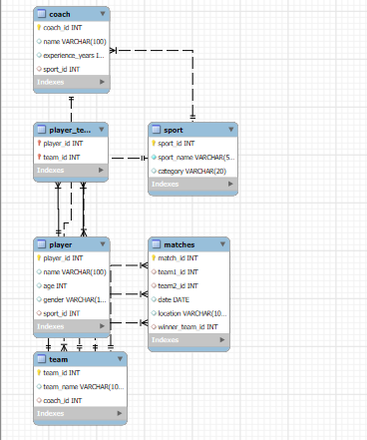

**CREATE DATABASE SportManagement;**

**USE SportManagement;**

**CREATE TABLE Sport (**

**sport_id INT AUTO_INCREMENT PRIMARY KEY,**

**sport_name VARCHAR(50) NOT NULL,**

**category VARCHAR(20)**

**);**

**CREATE TABLE Player (**

**player_id INT AUTO_INCREMENT PRIMARY KEY,**

**name VARCHAR(100),**

**age INT,**

**gender VARCHAR(10),**

**sport_id INT,**

**FOREIGN KEY (sport_id) REFERENCES Sport(sport_id)**

**);**

**CREATE TABLE Coach (**

**coach_id INT AUTO_INCREMENT PRIMARY KEY,**

**name VARCHAR(100),**

**experience_years INT,**

**sport_id INT,**

**FOREIGN KEY (sport_id) REFERENCES Sport(sport_id)**

**);**

**CREATE TABLE Team (**

**team_id INT AUTO_INCREMENT PRIMARY KEY,**

**team_name VARCHAR(100),**

**coach_id INT,**

**FOREIGN KEY (coach_id) REFERENCES Coach(coach_id)**

**);**

**CREATE TABLE Player_Team (**

**player_id INT,**

**team_id INT,**

**PRIMARY KEY (player_id, team_id),**

**FOREIGN KEY (player_id) REFERENCES Player(player_id),**

**FOREIGN KEY (team_id) REFERENCES Team(team_id)**

**);**

**CREATE TABLE Matches (**

**match_id INT AUTO_INCREMENT PRIMARY KEY,**

**team1_id INT,**

**team2_id INT,**

**date DATE,**

**location VARCHAR(100),**

**winner_team_id INT,**

**FOREIGN KEY (team1_id) REFERENCES Team(team_id),**

**FOREIGN KEY (team2_id) REFERENCES Team(team_id),**

**FOREIGN KEY (winner_team_id) REFERENCES Team(team_id)**

**);**

**INSERT INTO Sport (sport_name, category) VALUES**

**('Football', 'Outdoor'),**

**('Basketball', 'Indoor'),**

**('Cricket', 'Outdoor'),**

**('Tennis', 'Outdoor'),**

**('Volleyball', 'Indoor'),**

**('Badminton', 'Indoor'),**

**('Hockey', 'Outdoor'),**

**('Table Tennis', 'Indoor'),**

**('Rugby', 'Outdoor'),**

**('Handball', 'Indoor');**

**INSERT INTO Coach (name, experience_years, sport_id) VALUES**

**('John Doe', 10, 1),**

**('Emily Smith', 8, 2),**

**('Raj Patel', 12, 3),**

**('Sophia Green', 5, 4),**

**('Liam Brown', 7, 5),**

**('Emma Johnson', 9, 6),**

**('William Lee', 6, 7),**

**('Olivia Davis', 11, 8),**

**('Noah Wilson', 3, 9),**

**('Ava Martinez', 4, 10);**

**INSERT INTO Team (team_name, coach_id) VALUES**

**('Tigers', 1),**

**('Eagles', 2),**

**('Warriors', 3),**

**('Panthers', 4),**

**('Sharks', 5),**

**('Dragons', 6),**

**('Falcons', 7),**

**('Lions', 8),**

**('Bulls', 9),**

**('Wolves', 10);**

**INSERT INTO Player (name, age, gender, sport_id) VALUES**

**('Alice', 22, 'Female', 2),**

**('Bob', 24, 'Male', 1),**

**('Charlie', 21, 'Male', 1),**

**('Diana', 23, 'Female', 2),**

**('Ethan', 25, 'Male', 3),**

**('Fiona', 20, 'Female', 4),**

**('George', 26, 'Male', 5),**

**('Hannah', 22, 'Female', 6),**

**('Ian', 27, 'Male', 7),**

**('Julia', 21, 'Female', 8),**

**('Kevin', 23, 'Male', 9),**

**('Laura', 24, 'Female', 10),**

**('Mike', 22, 'Male', 1),**

**('Nina', 23, 'Female', 2),**

**('Oscar', 20, 'Male', 3);**

**INSERT INTO Player_Team VALUES**

**(1, 2), (2, 1), (3, 1), (4, 2),**

**(5, 3), (6, 4), (7, 5), (8, 6),**

**(9, 7), (10, 8), (11, 9), (12, 10),**

**(13, 1), (14, 2), (15, 3);**

**INSERT INTO Matches (team1_id, team2_id, date, location, winner_team_id) VALUES**

**(1, 2, '2025-05-10', 'Stadium A', 1),**

**(2, 1, '2025-05-17', 'Stadium B', 2),**

**(3, 4, '2025-06-01', 'Stadium C', 3),**

**(5, 6, '2025-06-05', 'Stadium D', 6),**

**(7, 8, '2025-06-10', 'Stadium E', 7),**

**(9, 10, '2025-06-12', 'Stadium F', 9),**

**(1, 3, '2025-06-15', 'Stadium A', 1),**

**(4, 2, '2025-06-18', 'Stadium B', 4),**

**(5, 7, '2025-06-21', 'Stadium C', 5),**

**(6, 8, '2025-06-25', 'Stadium D', 8);**

**SELECT * FROM Player;**

**1. List all players**

**SELECT * FROM Player;**

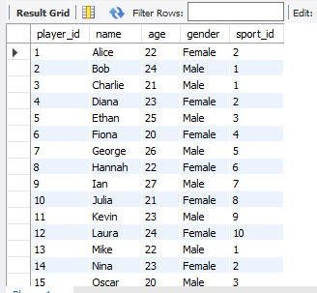

**2. List all teams with their coach name**

**SELECT T.team_name, C.name AS coach_name**

**FROM Team T JOIN Coach C ON T.coach_id = C.coach_id;**

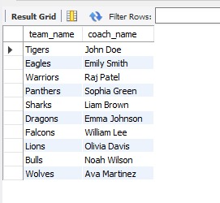

**3. List all matches with team names and winner**

**SELECT M.date, T1.team_name AS Team1, T2.team_name AS Team2, TW.team_name AS Winner**

**FROM Matches M**

**JOIN Team T1 ON M.team1_id = T1.team_id**

**JOIN Team T2 ON M.team2_id = T2.team_id**

**JOIN Team TW ON M.winner_team_id = TW.team_id;**

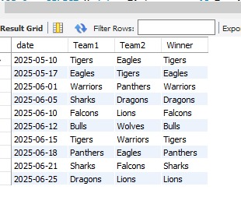

**4. Show all players in team 'Tigers'**

**SELECT P.name**

**FROM Player P**

**JOIN Player_Team PT ON P.player_id = PT.player_id**

**JOIN Team T ON PT.team_id = T.team_id**

**WHERE T.team_name = 'Tigers';**

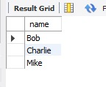

**5. List all players of a particular sport (e.g., Football)**

**SELECT P.name, S.sport_name**

**FROM Player P**

**JOIN Sport S ON P.sport_id = S.sport_id**

**WHERE S.sport_name = 'Football';**

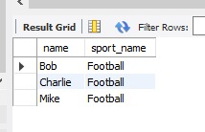

**6. Show total matches played by each team**

**SELECT T.team_name, COUNT(*) AS matches_played**

**FROM Team T**

**JOIN Matches M ON T.team_id = M.team1_id OR T.team_id = M.team2_id**

**GROUP BY T.team_name;**

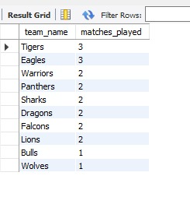

**7. Show win count for each team**

**SELECT T.team_name, COUNT(*) AS wins**

**FROM Team T**

**JOIN Matches M ON T.team_id = M.winner_team_id**

**GROUP BY T.team_name;**

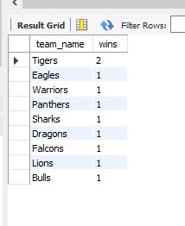

**8. Find coaches with more than 5 years experience**

**SELECT name FROM Coach WHERE experience_years > 5;**

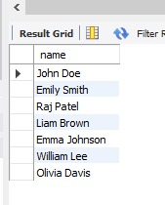

**9. Find all indoor sports**

**SELECT sport_name FROM Sport WHERE category = 'Indoor';**

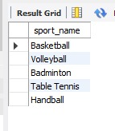

**10. List all teams coached by 'Emily Smith'**

**SELECT team_name FROM Team**

**JOIN Coach ON Team.coach_id = Coach.coach_id**

**WHERE Coach.name = 'Emily Smith';**

